**CASE STUDY**

**OF**

**TAXI**

**MANAGEMENT**

**SYSTEM**

**USING**

**RELATIONAL**

**DATABASE DESIGN**

**Case Study in Relational Database Design**

* **Title:** Taxi Management System
* **Student Names:** Pranav Jindal (2010990538)

Naman Verma (2010990472)

Preetinder Singh (2010990548)

Paras Mahajan (2010990516)

Nikhil Chauhan (2010990493)

* **Guide:** Chaitanya Singla (E1116663)

**Contents**

* **Abstract………………………………………………………………………….**
* **Acknowledgments……………………………………………………………….**
* **Chapter 1: Introduction………………………………………………………...**
* **Chapter 2: Name of the Case Study………………………………………...….**

1. Case Study Informal Description………………………………………….
2. Terminologies and Symbols of ER diagram……………………………….
3. Case Study Logical Model (ER Diagram) ………………………………...
4. Case Study Physical Schema………………………………………………
5. Case Study Interactive Queries…………………………………………….

* **Conclusion……………………………………………………………………….**
* **Bibliography…………………………………………………………………….Abstract**

The objective of this thesis is to get some good hands on for creating the relational schemas and implementing the data extraction queries related to them. One case study “Taxi Management System” is presented. Input for this case study is taken from its informal specification to a relational schema using entity-relationship modeling and its translation to the relational model, to database schema, to implementation of the database, to interactive SQL querying of the installed database (Oracle).

**Acknowledgement**

We would like to express our gratitude to all those who made it possible to complete this thesis in particular to our supervisor Chaitanya Singla sir. We would also like to thank our family for their understanding and continuous support.

**Chapter 1: Introduction**

* **Database Management System:**

Database Management Systems (DBMS) are software systems used to store, retrieve, and run queries on data. A DBMS serves as an interface between an end-user and a database, allowing users to create, read, update, and delete data in the database. DBMS manages the data, the database engine, and the database schema, allowing for data to be manipulated or extracted by users and other programs. This helps provide data security, data integrity, concurrency, and uniform data administration procedures.

* **Relational Database Management System:**

A Relational Database Management System (RDBMS) is a program that allows you to create, update, and administer a relational database. Most relational database management systems use the SQL language to access the database.

* **ER Diagram:**

Attribute

Entity

Relationship

* 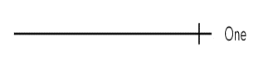

One relation

* 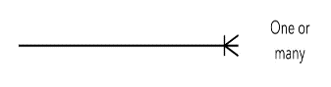

One or many relation

* **Objective of Case Study:**

Objective of this case study is to get a little taste of how the designing process of database system goes and how all the data insertions, updates and fetching are performed. In this we also had a hands-on practice of how to design the ER diagram of our database.

**Chapter 2: Taxi Management System**

1. **Case Study Informal Description:**

We have planned a taxi management system in which we are storing the information of our taxies and all the drivers. In our system we, are also storing the details of our customers and all about their ride information. We are also having a feedback section in which we are storing the feedback from our customers regarding their experience with the driver and his/her skills in their journey.

1. **Case Study Logical Model:**

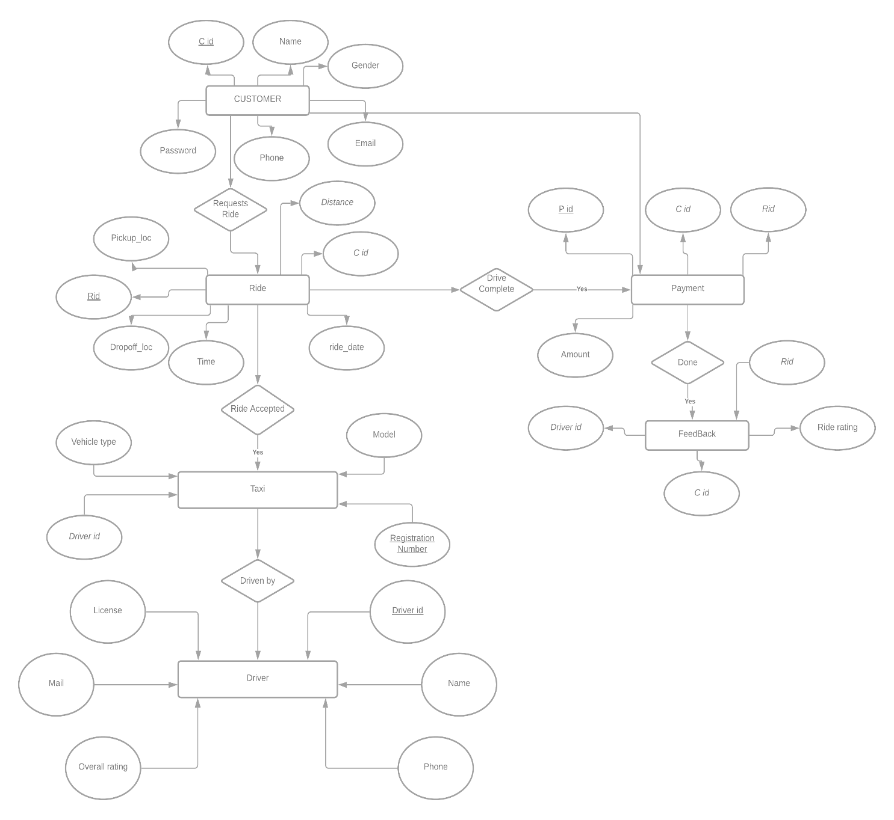

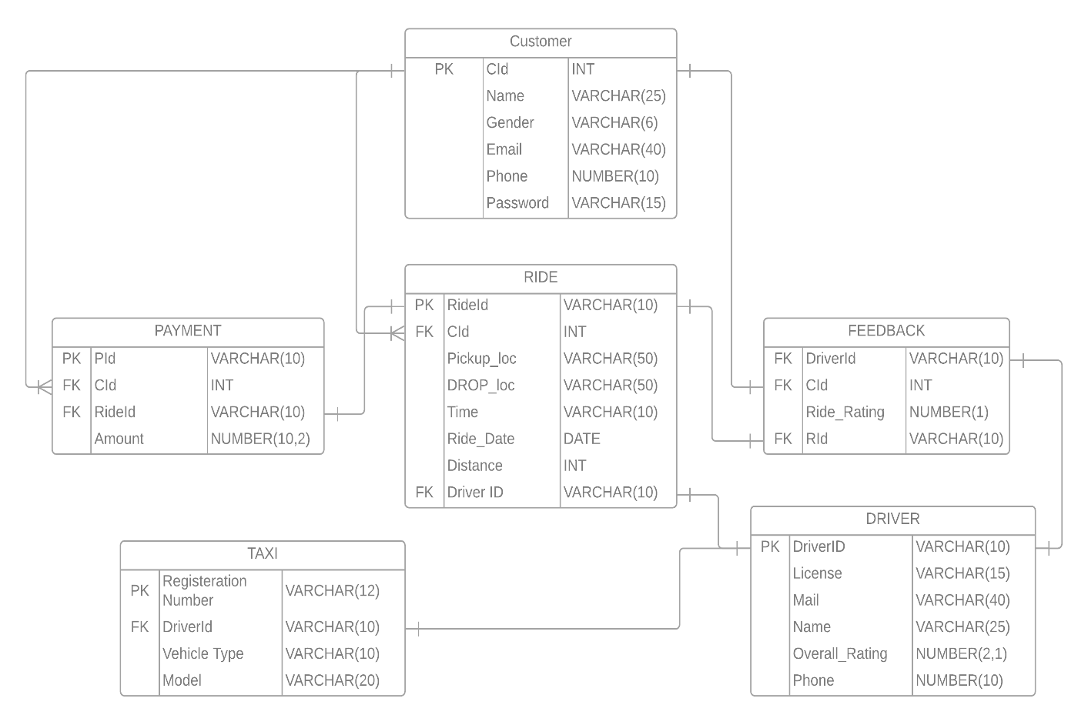

1. **Case Study Physical Model:**

* **Customer Table:**

create table customer (

cid int,

name varchar (25) not null,

gender varchar (6) not null,

email varchar (40) not null check (email like '%@%'),

phone number (10) check (length(phone)=10),

password varchar (15),

constraint cust_id primary key(cid)

);

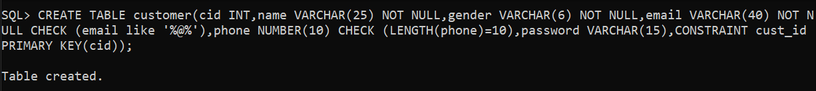

insert into customer values (

101,'rupesh dev mand', 'male', 'rupesh01@gmail.com', 6518734985, 'abc1238jb'

);



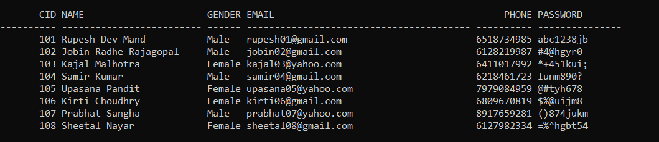

* **Driver Table:**

create table driver (

d_id varchar (10),

license varchar (15),

name varchar (25) not null,

phone number (10) check (length(phone)=10),

mail varchar (40) not null check (mail like '%@%'),

overall_rating number (2,1),

constraint driver_id primary key(d_id)

);



insert into driver values (

‘D101', 'PB7028718', 'Manpreet Singh', 7136768490, 'manpreet01@gmail.com', 4.7

);



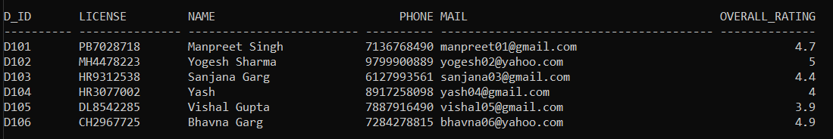

* **Ride Table:**

create table ride (

rid varchar (10),

cid int,

pickup_loc varchar (50) not null,

dropoff_loc varchar (50) not null,

ride_date date,

time varchar (10),

distance int,

d_id varchar (10),

constraint ride_id primary key(rid),

constraint cust_id1 foreign key(cid) references customer(cid),

constraint driver_id1 foreign key(d_id) references driver(d_id)

);

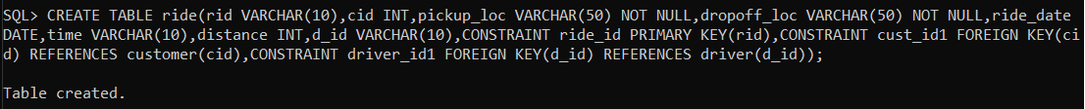

insert into ride values (

‘R101', 101, 'Nabha', 'Patiala’, to_date ('12-04-2021', 'dd-mm-yyyy'),

to_char (to_date ('1325', 'hh24mi'),'hh24:mi'), 30, 'D101'

);



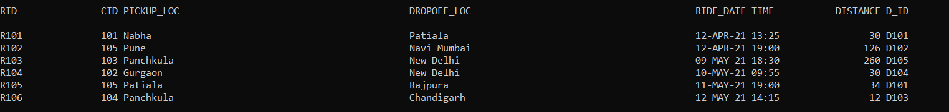

* **Payment Table:**

create table payment (

pid varchar (10),

rid varchar (10),

cid int,

amount number (10,2),

constraint pay_id primary key(pid),

constraint ride_id1 foreign key(rid) references ride(rid),

constraint cust_id2 foreign key(cid) references customer(cid)

);



insert into payment values (

'P101', 'R101', 101, 1000.0

);

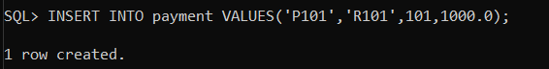

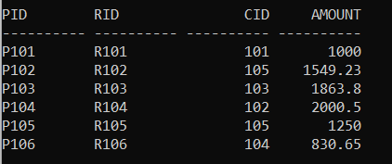

* **Taxi Table:**

create table taxi (

regis_number varchar (12),

model varchar (20),

vehicle_type varchar (10),

d_id varchar (10),

constraint regis_no primary key(regis_number),

constraint driver_id2 foreign key(d_id) references driver(d_id)

);



insert into taxi values (

'PB11CY4512','Altroz','Hatchback','D101'

);

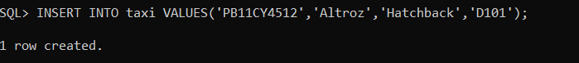

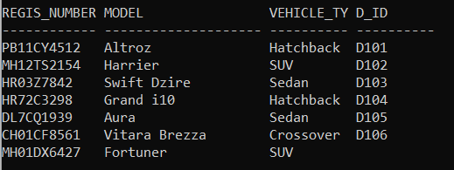

* **Feedback Table:**

create table feedback (

d_id varchar (10),

cid int,

rid varchar (10),

ride_rating number (1),

constraint driver_id3 foreign key(d_id) references driver(d_id),

constraint cust_id3 foreign key(cid) references customer(cid),

constraint ride_id2 foreign key(rid) references ride(rid)

);



insert into feedback values (

'D101',101,'R101',4

);

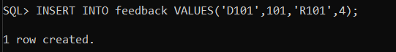

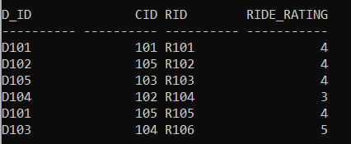

1. **Case Study Interactive Queries:**

* **Query 1:** Find the female customers who had a ride on 09/05/2021.

= select cid, name from customer natural join ride where gender='Female' and ride_date=to_date('09-05-2021', 'dd-mm-yyyy');

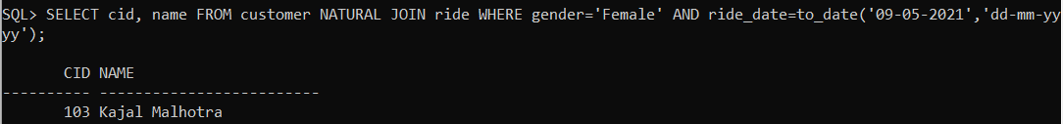

* **Query 2:** Find name of the drivers and their taxi whose overall rating is 5.

= select regis_number, name from taxi inner join driver on taxi.d_id = driver.d_id where overall_rating=5;

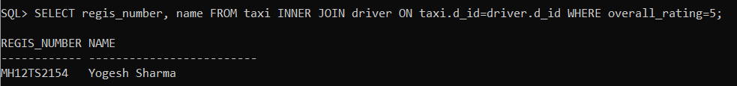

* **Query 3:** Find count of all the vehicle types.

= select vehicle_type, count(regis_number) from taxi group by vehicle_type;

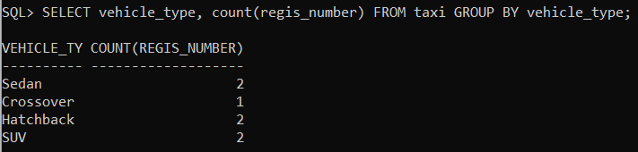

* **Query 4:** Find all the pickup points with their respective number of customers.

**=** select pickup_loc, count(cid) from customer natural join ride group by pickup_loc;

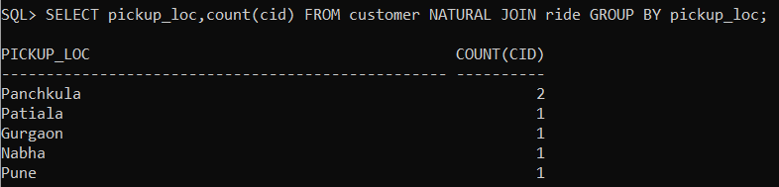

* **Query 5:** Find count of SUV's.

**=** select count(regis_number) as "No. of SUV's" from taxi group by vehicle_type having vehicle_type='SUV';

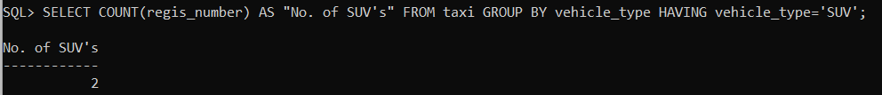

* **Query 6:** Find phone, email of the customer who have rated their ride with 3 or more stars.

= select phone,email from customer where cid=(select cid from feedback where ride_rating<=3);

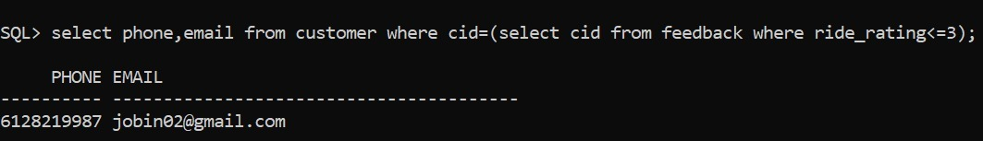

* **Query 7:** Find email ids of customers who paid ride amount >=1300.

**=** select email from customer inner join payment on customer.cid=payment.cid where amount>=1300;

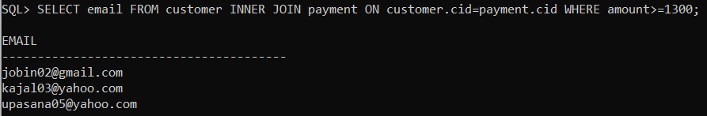

* **Query 8:** Find details of the driver who drives the car with registration number = “MH12TS2154”.

**=** select * from driver inner join taxi on driver.d_id=taxi.d_id where regis_ number = 'MH12TS2154';



* **Query 9:** Find name, gender of customer who requested ride after 18:00hrs.

**=** select name, gender from customer inner join ride on customer.cid=ride.cid where time>'1800';

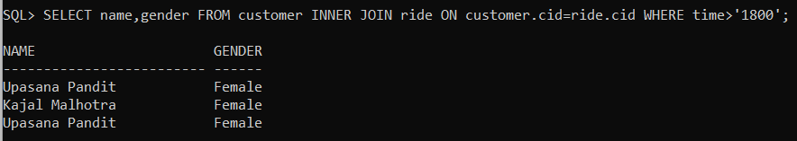

**Conclusion**

While working on this project, we learnt a lot about creating a database and implementing all the queries related to creation of database, modifying it and fetching the data from it. We have a good hold on the concepts related to ER diagram now.

**Bibliography**

* Database System Concepts’, Abraham Silberschatz, Henry F. Korth, Sudharsan, McGraw- Hill, Seventh Edition.
* 'An Introduction to Database Systems', C.J.Date , O'Reilly Media, Eighth Edition.
* google.com